CHAPTER-1

CHAPTER-1

Introduction of Bright Ideas Consulting:

* Bright Ideas Consulting Ltd. creates innovative, evidence-based solutions, to enable organisations and the individuals who interact with them to thrive. We predominantly work with organisations who have a social mission including voluntary & community sector organisations, public sector agencies and social business.
* Our main areas of services include; * Organisational Development & Change * Research Evaluation & Impact Assessment * Strategy & Business Planning * Financial Sustainability & Income Diversification for voluntary sector organisations and social enterprise * Psychometric Assessment * Psychological Research.

Purpose of Bright Ideas Consulting:

* Specifically it has three main aims: 1 **To offer leadership on an interim or short term basis to drive delivery of your development program and goals** 2 To offer high level assistance on projects, programs, staffing or strategic issues - when you need it 3 To produce homes for sale Bright ideas is owned by Martin
* After graduating from the University of Athens and concluding his MBA Studies at **SDA Bocconi** University in Milano, George initially worked in the Business Machines sector (Canon Copiers, Fax Machines and Printing Systems) as a Salesman, Sales Manager and Sales Director.
* The next step of his career was **Sales Division Management of Consumer Electronics Products** (Canon Photo-Video, Toshiba TV & Monitors, Pioneer Sound & Vision Products). The additional task of this particular period included the merge of 3 different companies and their respective Sales Divisions.
* **In 2010, he founded Net Spirit S.A with his brother Dionysius and the journey of e-Commerce begun.** Successfully launched and operated innovative pure e-commerce sites such as **Welovetoys.gr** pioneering e-tail of Toys in 2011, **Welovebabies.gr** revolutionizing Diapers & Baby Care sales in 2012 and **Welovesupermarket.gr** in 2013, one of the first e-supermarkets in Greece, a pure e-Grocery Player which achieved client base of more than 100,000 subscribed users with top conversion and customer loyalty & satisfaction rates. In 2017 a strategic alliance with **My Market** (4th Physical Grocery Retailer in Greece) was agreed, which led to the creation of **eshop.mymarket.gr** and the achievement of a 25% market share of the Greek e-grocery market for 2019.
* After this success, My market acquired 100% of the company at the end 2020.
* The aftermath of this journey was the foundation of **Bright Ideas Consulting** with the scope of sharing his experience to help customers avoid mistakes, use tested methods to solve their issues and thus achieve their goals for growth, digital transformation and overall success in their business objectives.

CHAPTER-2

Problem Dedinition &Design Thinking:

2.1Empathy map

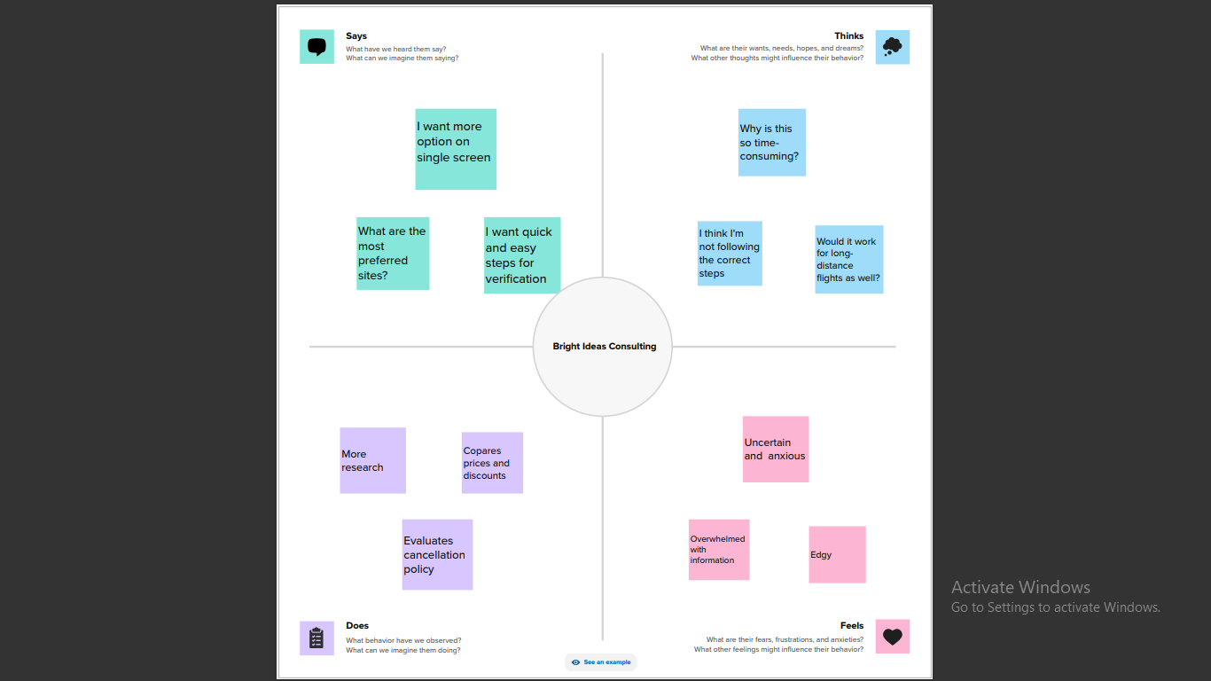

2.2 Ideation & Brainstorm Map: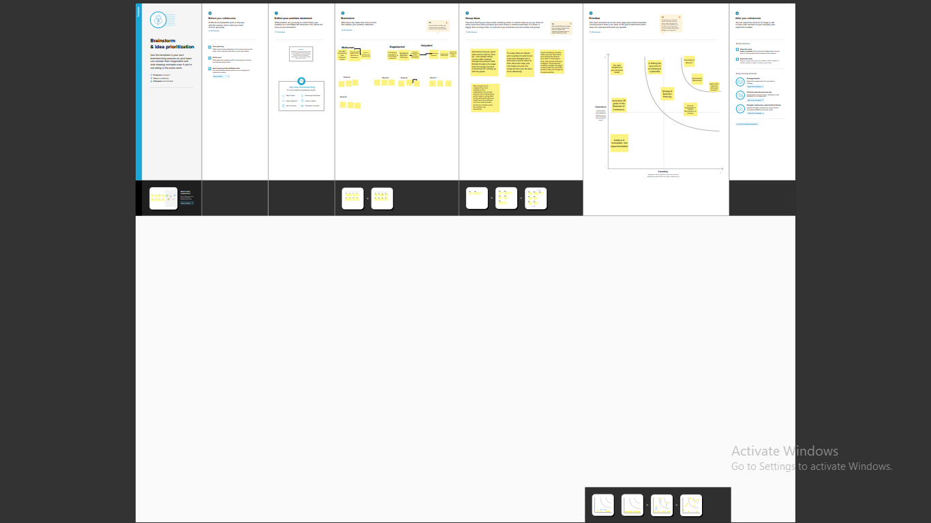

**CHAPTER - 3**

**Result:**

3.1 Output:

Profit and loss a\c

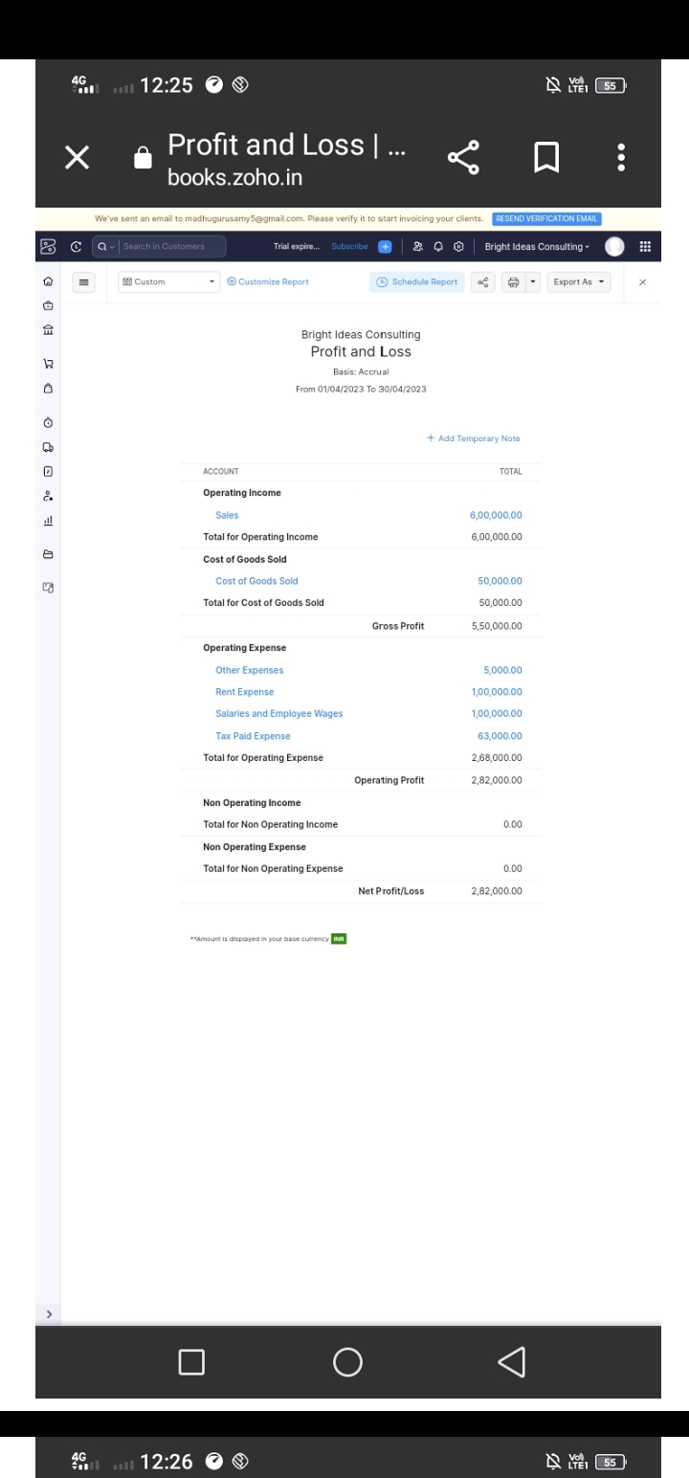

**3.2 Balance Sheet:**

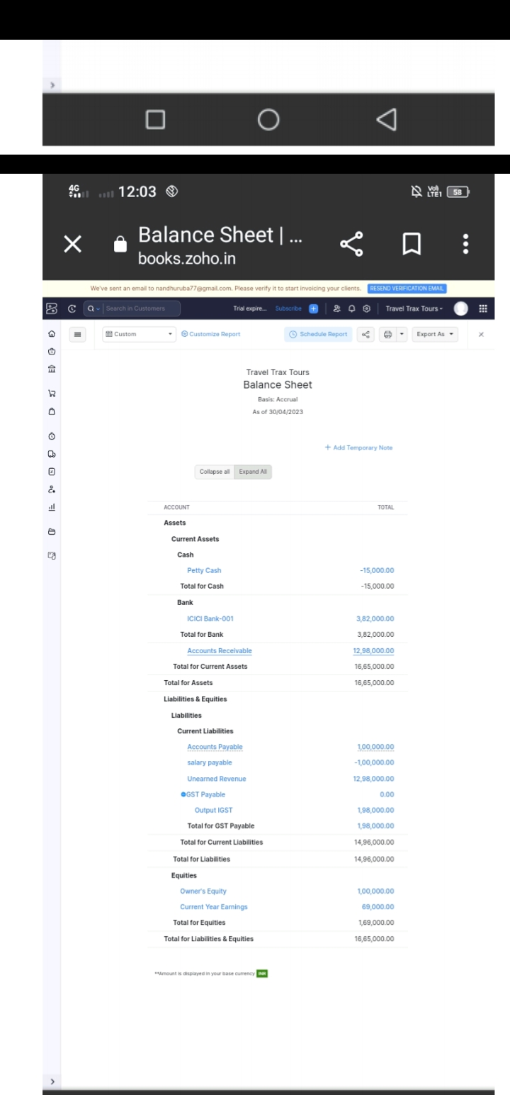

CHAPTER-4

**Advantages & Disadvantages:**

**Advantages of Bright Ideas Consulting:**

* Bright Ideas Medical Consulting can **augment the work you and your team are already doing and offer strategic plans along with implementation steps**.
* No practice is too small or too large for us.
* Our services are customized, affordable, and designed to meet your unique needs.
* Bright idea features **discussion management**, which provides users with a collaboration platform to share and comment on ideas.
* Users to create microsites focused on specific issues or challenges.
* Bright Ideas Consultancy call upon experienced professionals to assist you with all aspects of developing, from design and strategy to cost and procurement.
* It’s not just about putting your customers first, says Brian Mangum. You also need to have compassion and empathy for what they’re experiencing. Only then can you provide good service.

Disadvantages of Bright Ideas Consulting:

* Bright idea makes most tasks difficult. The backend is outdated and not intuitive. Setting up a site is time consuming and you have three different setup areas.
* There are many advantages and disadvantages to working in consulting. Some of the advantages include: The opportunity.
* While many people make no distinction between creativity and innovation, in reality there is a huge difference between the two.
* While many people make no distinction between creativity and innovation, in reality there is a huge difference between the two.
* Not all bright ideas are innovative, even if they appear to be quite creative.
* In terms of business and commerce, a creative idea stops short of being ground-breaking.
* if consumers aren’t willing to buy the resulting product or service readily and enthusiastically
* Social marketers today need to break the rules of traditional communication streams.
* manage their communities differently, and become truly innovative instead of just relying on creativity to alter the market and sell their product.
* Kaye and Kelpie are working with companies to shine a brighter light on brands worldwide

CHAPTER-5

Application of Bright Ideas Consulting:

* To offer leadership on an interim or short term basis to drive delivery of your development program and goals.
* To offer high level assistance on projects, programs, staffing or strategic issues - when you need it
* To produce homes for sale
* Bright ideas are owned by Martin Hawthorne, a housing development professional with over 30 years’ experience.
* He coordinates all the company’s activity and can call upon the expertise of many other highly qualified and experienced colleagues to help tackle any issue you might have in the world of development.
* Bright Ideas can help you when you need us - you might have a staff shortage and need an experienced senior professional to help deliver your development requirements.
* This might mean a helping hand during a merger, a reorganisation, cover for maternity leave or to fill a gap after a senior member of staff has left. We can be brought in on a short-term basis to help offer strategic and practical help, as required.
* You might also want a second opinion on an important scheme, or want some help getting a scheme going (no matter how large or small) and need some extra resource.
* Bright Ideas is looking for sites to develop. We are keen on progressing smaller, niche sites for sale and also offering our services for larger joint venture arrangements. If you need a partner, some advice or want to sell a site, get in touch with us today.
* Bright Ideas can call upon experienced professionals to help you with all aspects of development and can advise on all areas related to housing developments,
* including: • strategy • public sector and HCA issues • scheme risk analysis and appraisal • design • cost • procurement.
* Bright Ideas is proud to announce that [North Star Housing Group](https://uk.linkedin.com/company/north-star-housing-group?trk=organization_guest_main-feed-card-text) has entered into contract to buy 22 homes in the Bohol Village development .
* We would also like to thank [Angela Lockwood](https://uk.linkedin.com/in/angela-lockwood-3760a719?trk=organization_guest_main-feed-card-text) the CEO of North Star and the Board of North Star along with [Emma Speight](https://uk.linkedin.com/in/emma-speight-29345b51?trk=organization_guest_main-feed-card-text).
* Sarah Fawcett and Lauren Kelly without whose help and patience this deal would not have happened.

CHAPTER-6

Conclusion of Bright Ideas Consulting:

* Wow! I cannot believe that the event consulting series has ended, and we have outlined the significant steps to take in planning a successful event.
* Each event is indeed different, but if you have a solid event plan, it is like a blueprint for building a house. Follow it as closely as possible, make adjustments as needed, and always keep your eye on the big picture.
* In this blog, we talk about the differences between these two jobs. We also explore how to decipher which Event Professional to hire for your event planning needs.
* Finding the right venue is always challenging, but it’s not impossible if you have a qualified event professional guiding you. Have a look at our [Ultimate List of Unique Venues](https://brightideasevents.com/news/bright-ideas-blog/the-ultimate-list-of-unique-event-venues-in-vancouver/) to see if you can find your perfect venue.
* Timing is everything, and in the event, biz timing is KEY! Planning the “perfect” takes experience and knowledge—nothing worse than a poorly designed schedule.
* A theme can make or break an event.The best kind of theme is one that weaves throughout the event's strategy. Here are our top [10 Award Winning Themes](https://brightideasevents.com/news/bright-ideas-blog/10-award-winning-event-themes/).
* The best kind of décor is interactive décor that engages the audience. An event professional will guide you on the best option, which can be tricky. Read about this Eco Friendly, winning décor strategy [here.](https://brightideasevents.com/news/bright-ideas-blog/an-eco-friendly-decor-idea-for-your-earth-day-event/)
* Our guests talk about food long after the event is over, so you had better get it right the first time. The wrong appetizers, crowded buffets and empty food stations are the death of your event.
* Most people don’t realize that selecting your entertainment is very important for the success of your event because if you include the wrong selection of joy, it may hinder guests' ability to mingle and network. Here’s a [list of hybrid and virtual entertainment](https://brightideasevents.com/news/bright-ideas-blog/10-event-entertainment-ideas-for-virtual-events-hybrid-events/) ideas.
* Using promotional products as giveaways is a tried and true marketing technique. However, giving out a bad giveaway can easily lead to it being ignored or, even worse, can damage your brand.
* It depends on what you need. You can purchase a package for a few hours if you need just a bit of guidance. However, if you need someone to map out the whole event plan and implement it, I can do that for you too.

CHAPTER-7

Future of Bright Ideas Consulting:

* The way the world thinks about energy is changing rapidly, challenging operating paradigms in industries that have existed in some cases for well over a hundred years.
* While many of these ideas are well documented and include familiar topics—such as the transition to renewables, rising customer expectations, and technology changes driven by Industry 4.0—their location, timing and impact are harder to predict.
* To anticipate these requires deep understanding not just of global trends but of their local applicability. Who benefits from these changes will be the result of an interconnected set of choices which appear far more varied and complex than those typical to the industry.
* Our ***Bright ideas: New perspectives on the future of Canada’s power sector series*** will take a look at some of these new ideas and explore the issues facing stakeholders and the options available to them.
* We’ll draw on case examples of how others have responded in similar situations, both inside and outside of the energy industry, to help illuminate a path forward.
* We provide a full range of property consultancy services that serve to deliver your development strategies.
* To offer leadership on an interim or short-term basis, driving delivery of development program and goals.
* To offer high-level assistance on projects, programs, staffing or strategic issues, whenever you need it.
* To design and develop homes so they are market-ready.
* We have a number of projects that are currently being undertaken across the country. These include whole villages that run on green energy, electrical vehicle charging, and commercial and domestic property developments.
* Bright Ideas Agency is an independent consulting company, owned and operated by Nick Decory, helping small businesses supercharge their productivity.
* Imagine a future where you're no longer focused on financial survival but on providing the best possible care for your patients.